**LOVELY PROFESSIONAL UNIVERSITIY**



PROJECT REPORT ON

**TIC-TAC-TOE GAME**

SUBJECT: PYTHON PROGRAMMING – INT213

FACULTY: ANKITA WADHAWAN

TEAM MEMBERS:

Roll NO. Reg. No. Name of Team Members

|  |  |  |
| --- | --- | --- |
| 62 | 11915171 | Kartik dixit |
| 14 | **11909497** | **Divya sharma** |
| 06 | **11909439** | **Aman tiwari** |

**TO WHOM IT MAY CONCERN**

I, Aman Tiwari on the behalf my fellow teammates, hereby declare that the work done by me and my teammates on **“TIC-TAC-TOE GAME”** in the guidance of Ankita Wadhawan**,** is a record of original work for the partial fulfilment of the requirements award of the degree, **B.Tech** .

**ACKNOWLEDGMENT**

We would like to acknowledge everyone who played a role in our tic-tac-toe game project accomplishments. First of all, my teachers, who gave us this project and she guided us well, how to code using python language, GUI and etc.

Secondly, our parents who supported us with love and resources.

Lastly, team members, each of whom has provided advice and guidance throughout the project work. Thank you all for your unwavering support.

**INDEX / TABLE OF CONTENT**

**1. INTRODUCTION**

**2. DATA FLOW DAIAGRAM**

**3. ER Diagrams**

**4. Methodology or technology used**

**5. Results**

**6. Screenshots of project**

**INTRODUCTUON **

**Tic-tac-toe** (American English), **noughts and crosses** (Commonwealth English), or **Xs and Os**, is a paper-and-pencil game for two players, *X* and *O*, who take turns marking the spaces in a 3×3 grid. The player who succeeds in placing three of their marks in a horizontal, vertical, or diagonal row is the winner. It is a solved game with a forced draw assuming best play from both players.

When considering only the state of the board, and after taking into account board symmetries (i.e. rotations and reflections), there are only 138 terminal board positions. A combinatorics study of the game shows that when "X" makes the first move every time, the game outcomes are as follows:[[14]](https://en.wikipedia.org/wiki/Tic-tac-toe" \l "cite_note-:0-14)

* 91 distinct positions are won by (X)
* 44 distinct positions are won by (O)
* 3 distinct positions are drawn (often called a "cat's game"

**DATA FLOW DIAGRAM**

**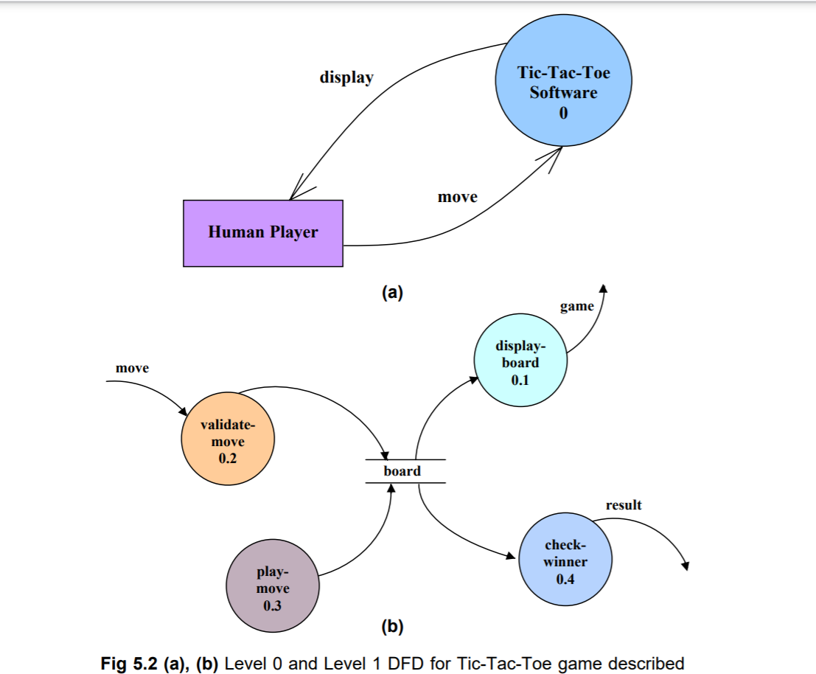**

**ER DIAGRAM**

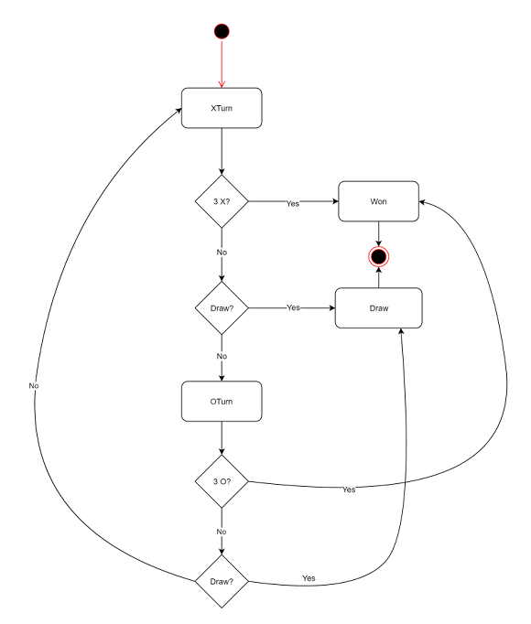

**RESULT**

In the conclusion of this prroject, we would like to say that Python is a fun and easy programming language and while creating a project like this, it has not just been a good experience but it also helped in the development of our creativity and logical thinking. We would be more than happy to work on other projects in Python because it’s just amazing to work with Python. The program is working and I hope, it’s also bug-free.

**Thank you for your attention**

**SCREENSHOTS**

**CODE:**

**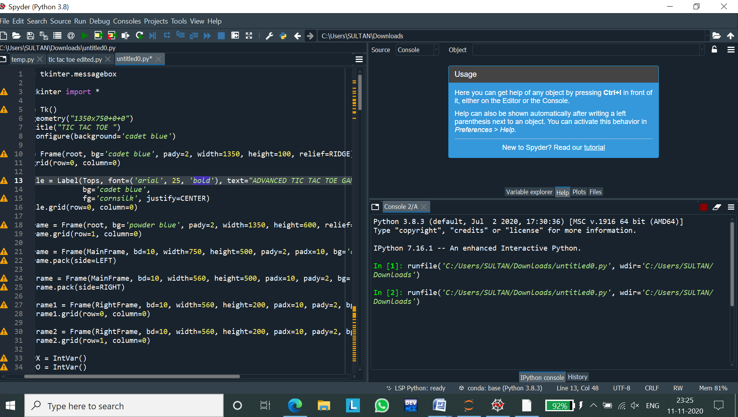**

**OUTPUT SCREEN:**

**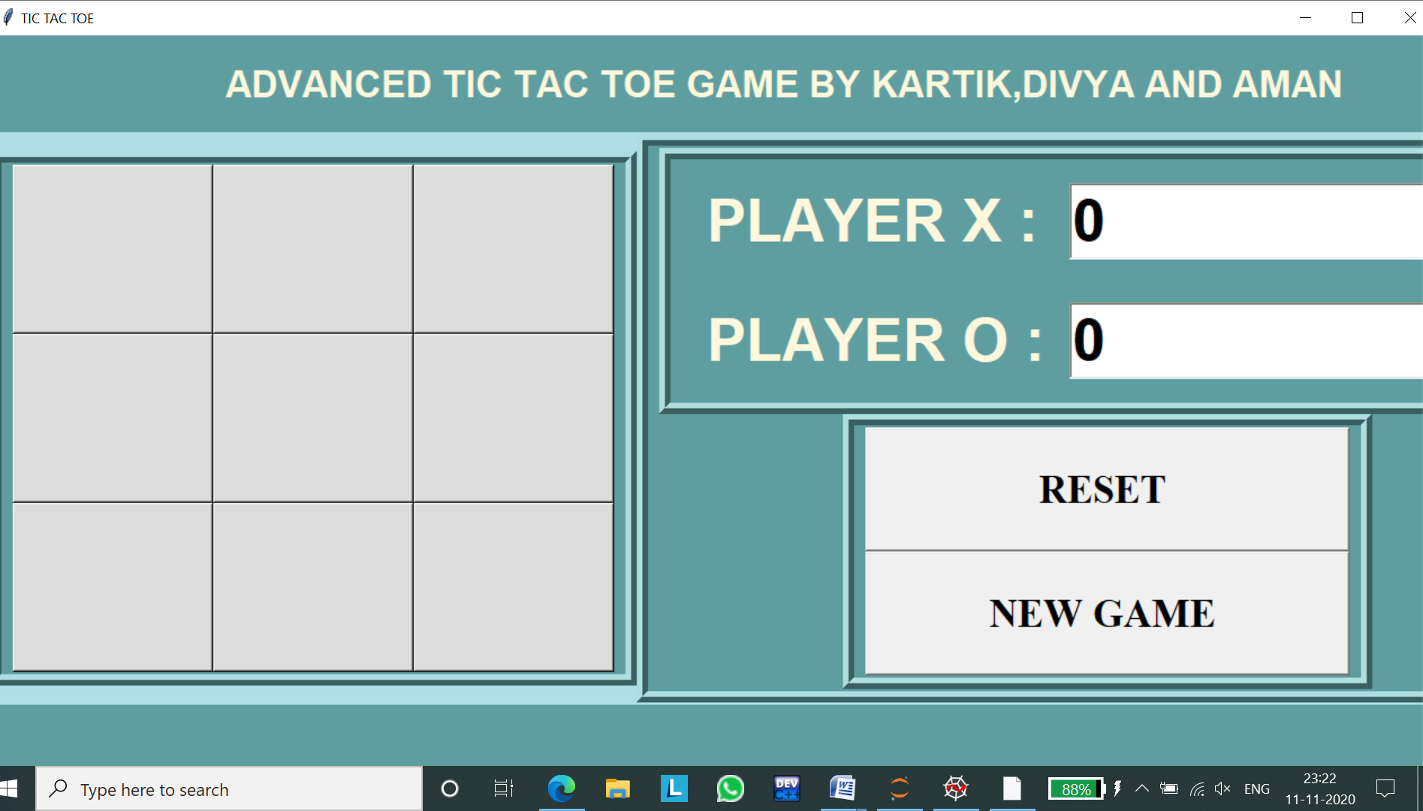**

**WHEN PLAYER X WIN:**

**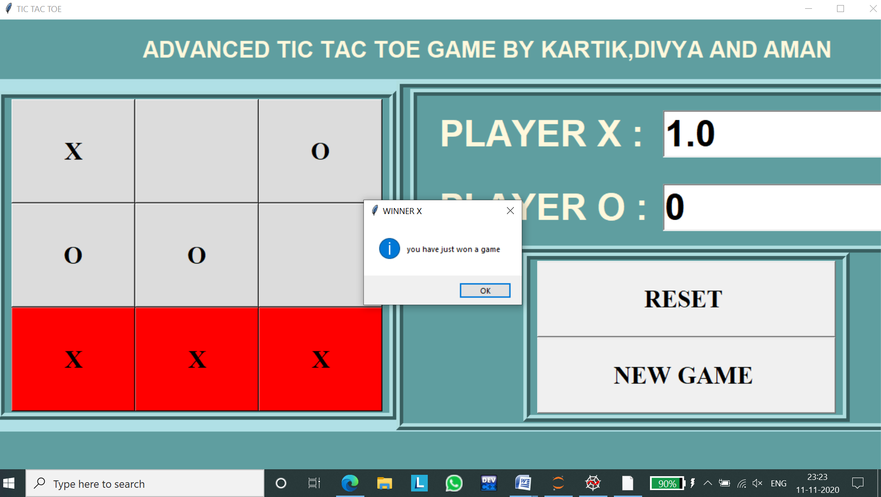**

**WHEN PLAYER X WIN AGAIN:**

**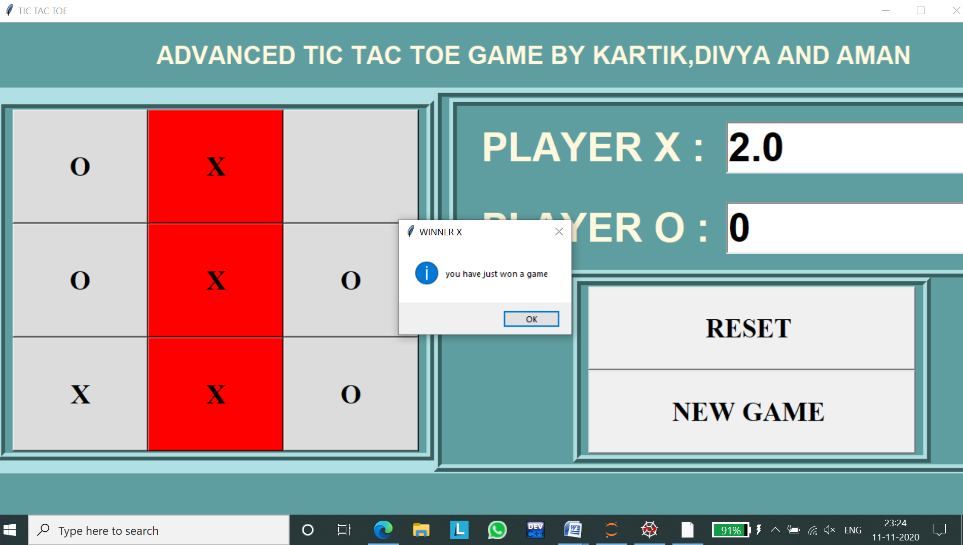**

**WHEN PLAYER O WIN:**

**